##### **Instagram User Analytics**

###### **A detailed report answering the questions below:**

**A) Marketing:** The marketing team wants to launch some campaigns, and they need your help with the following

1. **Rewarding Most Loyal Users:** People who have been using the platform for the longest time.  
   Your Task: Find the 5 oldest users of the Instagram from the database provide

**OUTPUT:**

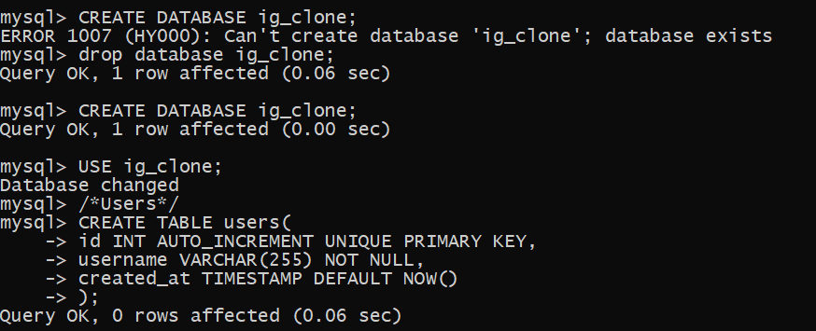

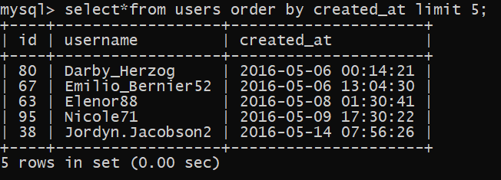

These are the five oldest users of Instagram from the database.

1. **Remind Inactive Users to Start Posting:** By sending them promotional emails to post their 1st photo.  
   Your Task: Find the users who have never posted a single photo on Instagram

**OUTPUT**: These are the users who have never posted a single photo on Instagram

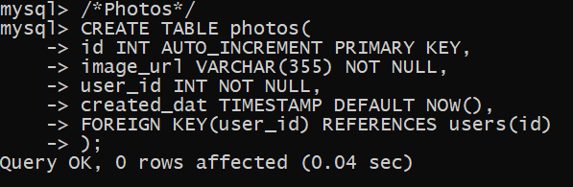

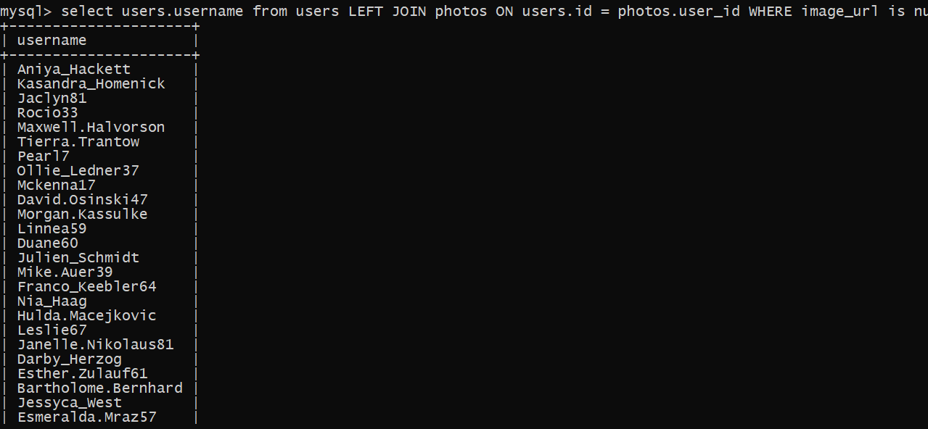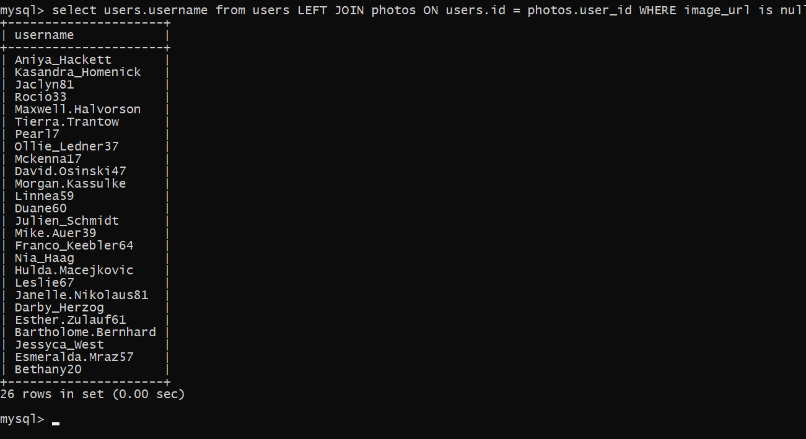

3

